Mendip East Newsletter – June 2021.

Avon and Somerset Police

Welcome to this month’s newsletter which is sent out from the team at the start of each month to keep you updated about what your local neighbourhood policing teams have been up to and anything we have planned for the future – If you no longer wish to receive this please let us know.

We are still facing challenges with covid restrictions and we are continuing to make sure people are safe.
The COVID restrictions have further eased on the 17th May as we move to step three on the Government’s roadmap out of lockdown. Moving to step three means that people can now socialise indoors in a group of up to six people or two households, including overnight stays and up to 30 people can meet outdoors. Other changes include the reopening of indoor entertainment and attractions, remaining accommodation, organised indoor adult sport, indoor hospitality and remaining outdoor entertainment.

For full details of what’s changed, visit the gov.uk website.

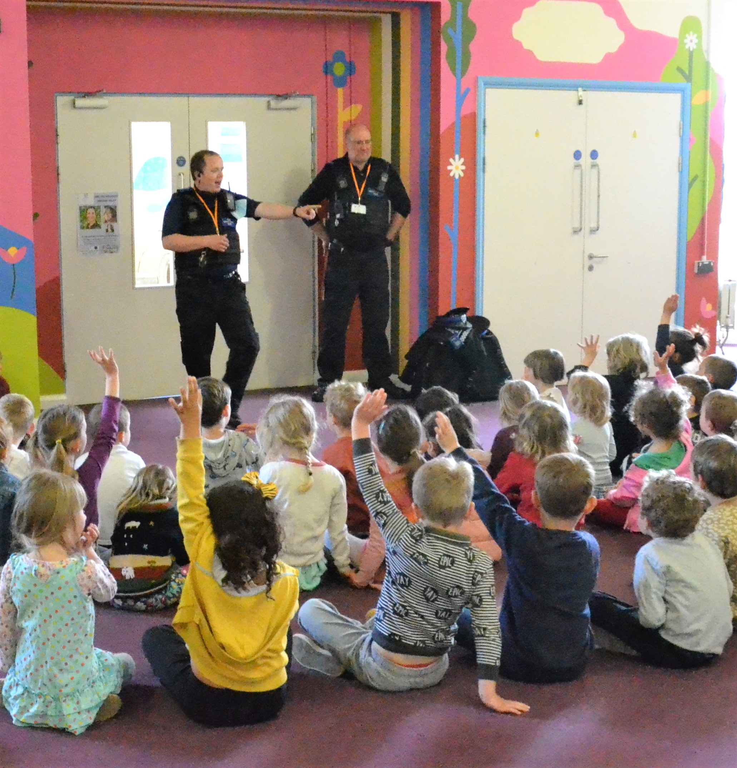
Frome Town –

May has been a busy month for the town, we have seen the COVID-19 restrictions ease again meaning lots of our businesses have welcomed customers back through their doors. It’s been great to see so much positivity and community spirit amongst the town. As a result of restrictions easing the team have been able re-establish our excellent working relationships with our schools. PCSO’s have been able to visit and deliver lessons within both Avanti Park School and Farleigh College. These engagements have varied from lessons surrounding the role of the Police and the neighbourhood team, to drug inputs as well as crime and consequence sessions.

Frome town continue to execute warrants for people who are sought for varying offences. This work culminated in the arrest of a male in the Frome area, who appeared in our forces top 20 list and was swiftly brought into Police Custody. We have also resumed our face to face engagements around the town, including holding sessions where members of the public can come and chat to us directly and raise any questions or concerns. Our aim is to continue and grow these sessions and would encourage everyone to visit our neighbourhood website.
https://www.avonandsomerset.police.uk/your-area/frome-town/ and also our Facebook and Twitter feeds for further information.

Frome and Shepton Rural-

We are tackling speeding in the locality with the assistance of Community Speed Watch (CSW) and visiting and educating repeat offenders. We are also working in partnership with Mendip Council to tackle fly tipping across our area, we suggest that members of the community download “Fix my street” app which they can use to report fly tipping.
We have seen a number of high value off road Motor cross bikes being stolen from garages and sheds. All lines of enquiries are being followed up, please be vigilant securing your outside buildings.

On Tuesday 18th May PCSO Guy DURY and PCSO Mike Storey from the Rural Crime Unit attended the main offices of Barber’s Farm Group. They met with the farm manager and discussed the possibility of farms on the Somerset/Dorset borders becoming members of Farm Watch. Mike has produced a comprehensive booklet, including contact details of Dorset, Devon and our own force Farm Watch details, which will be distributed to around 150 farms that the Barber Group deal with.

We are very keen to sign up as many farm’s to become members, and to encourage bordering farms to contact neighbouring force schemes.

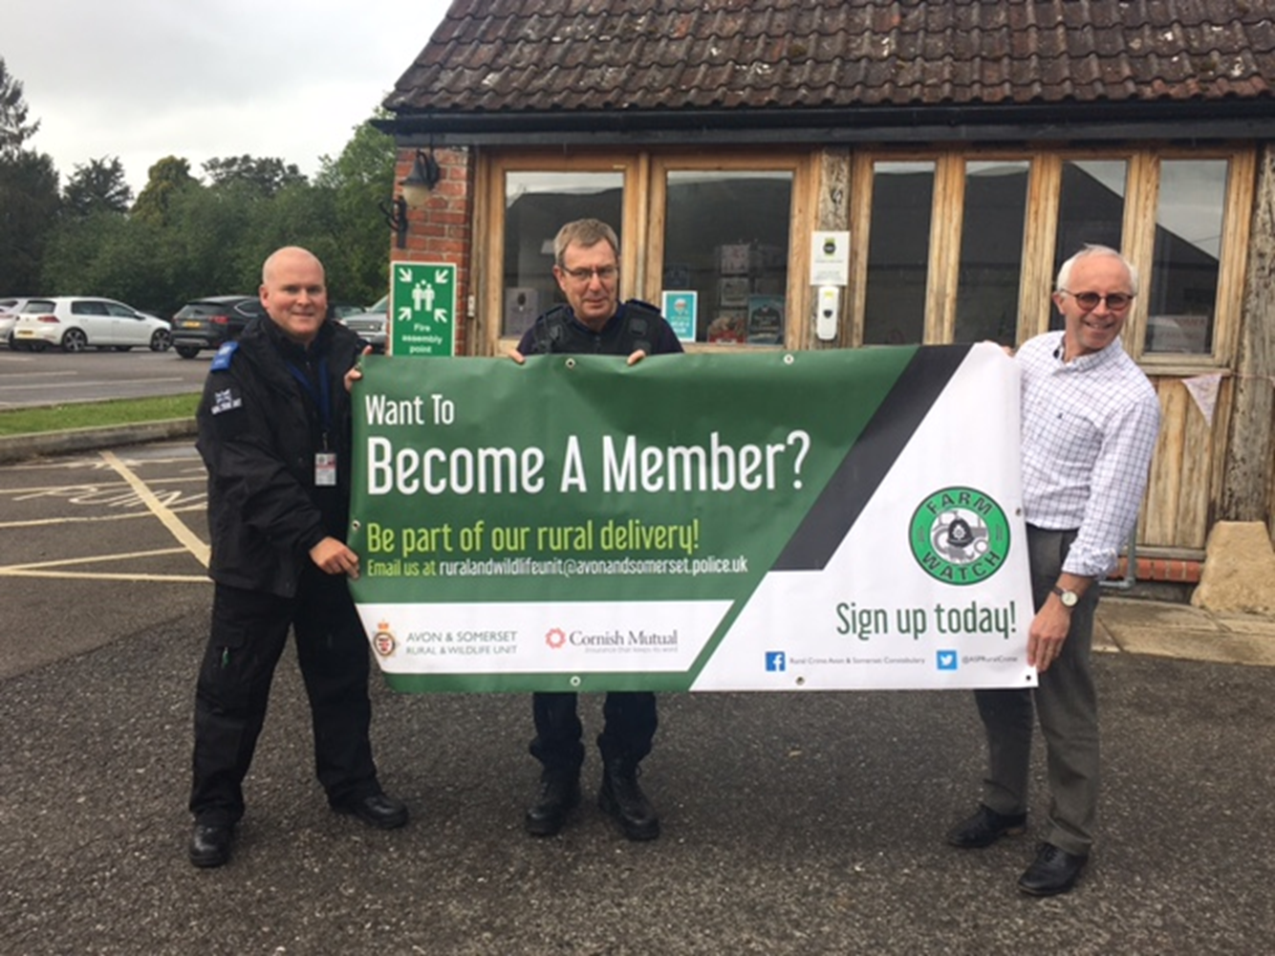

Shepton Mallet Town –

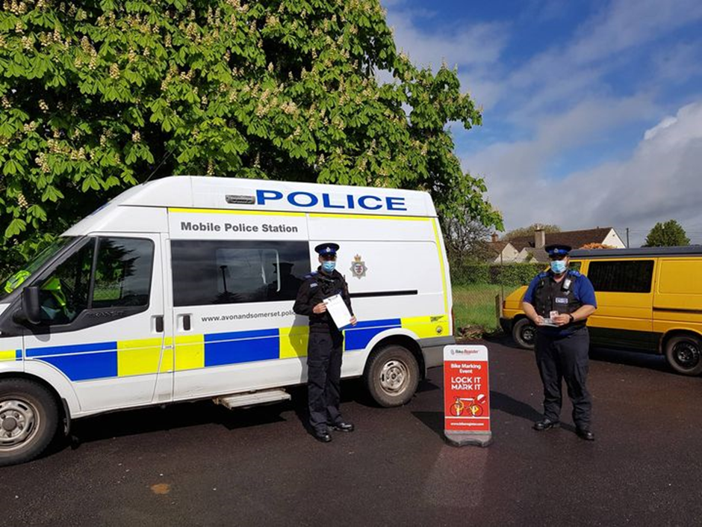
On Sunday 16th May 2021 the Shepton Mallet Neighbourhood Team held the first bike marking event of the year at West Shepton Mallet Skate Park. Despite the weather at times we had a great turn out! We utilised our social media platforms to promote the event and were able to mark 19 bicycles. We really enjoy doing these types of events and enjoyed meeting some lovely people and marked some awesome bikes. These types of community events are important to us as crime prevention is a big part of our role

The next bike marking event will be held on the 24th July at Shepton Mallet Skate Park. Please keep an eye our social media platforms for further information as we get closer to the date of the event.

Advice on why we do the bike marking events in Shepton Mallet.
The police regularly set up marking events in the summer months to provide cycle security advice and offer security marking and registration onto Bike Register’s online database. Registering your bike helps police and retailers identify and verify the legitimate owner of bikes that have been stolen or are being resold

Whilst not confirmed June may see the end of Covid restrictions across England. In addition there are local, national and international events that are likely to have an impact on the demand within your local Neighbourhood Policing Team (NPT) in the forthcoming months.
Any none urgent reports should continue to be made via 101 or the internet reporting form. For any emergencies please call 999.
Any concerns during this period regarding your local NPT should be directed towards NPT Supervisors of which details can be found below.

Mendip Neighbourhood Supervisor contact details:

Sergeant Rachel Clark
Email: Rachel.clark@avonandsomerset.police.uk

PCSO Supervisor Stephen Reading
Email: Stephen.reading@avonandsomerset.police.uk

Please remember to follow your local Facebook pages, these can now be found under: Frome Neighbourhood Policing and Mendip Neighbourhood Policing.

We continue to ask that members of the public who are witnessing any incidents to report them to us as they are happening, via 999, 101 or the Force Website.

