Mendip East Newsletter – March 2021.

Avon and Somerset Police

Welcome to the monthly newsletter, this will be sent out from the team at the start of each month to keep you updated about what your local neighbourhood policing team have been up to and anything we have planned for the future – If you no longer wish to receive this please let us know.
We have now seen our local Facebook pages change these can now be found under: Frome Neighbourhood Policing and Mendip Neighbourhood Policing.
We are still facing challenges with covid restrictions and we are continuing to make sure people are safe.

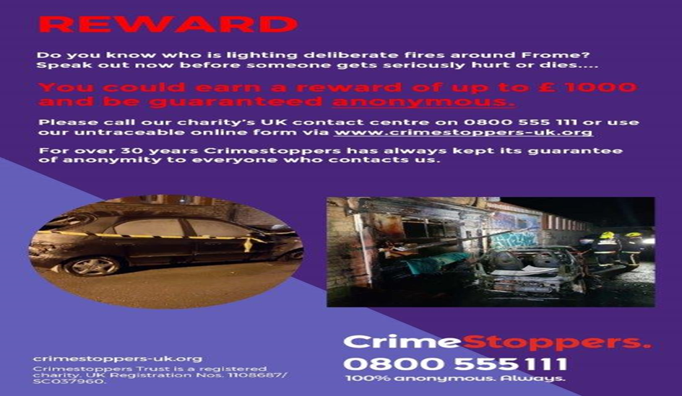
Frome Town –

As a result in an increase in incidents within the Frome open spaces we have erected a deployable Closed Circuit Television (CCTV) system in the area. Working in partnership with Frome Town Council it is hoped that the CCTV system will deter this behaviour from occurring and assist in keeping our communities park’s safe. Also in the town on Sun 21 February, A vehicle was deliberately ignited causing damage to it and another vehicle. The vehicles were parked in a car park in the Selwood Road area of the Town. Devon and Somerset Fire and Rescue Service attended and extinguished the fire and fortunately no one was hurt. As a result of this incident neighbourhood officers conducted enquiries at the scene and spoke to 70+ local residents. These enquires have brought to light lots of information which are being followed up by our team. The Crime stoppers appeal which has a reward of up to £1000 is also still active and any person coming forward with information leading to the apprehension of a suspect could be rewarded.

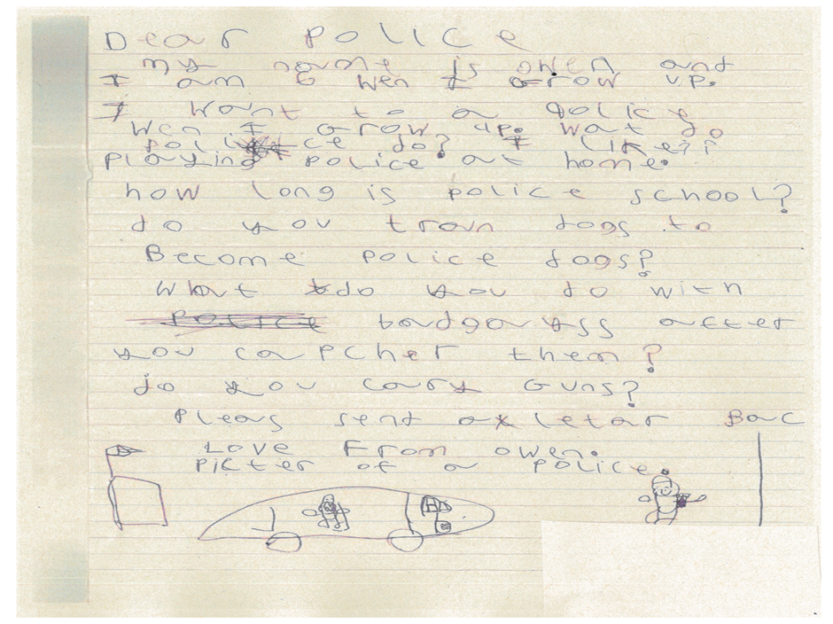

Elsewhere in Frome, the Town neighbourhood constables continue to execute warrants for offenders, the most recent of which was for an offender in Avon and Somerset’s top 20 most wanted. This warrant was executed effectively and meant that this offender had his day in court.

In lighter news, this week Frome Neighbourhood team had the pleasure to conduct a socially distanced delivery to one of our residents Owen. Six year old Owen aspires to become a Police Officer when he is old enough and recently sent us a letter asking us about our roles. We were so impressed with Owen’s letter that we delivered him some police themed goodies including a special police badge.

Frome and Shepton Rural-

Through continued patrolling and engagement with members of the rural community, we are very pleased that there seems to have been fewer incidents of activities such as poaching and coursing recently. However, we have become aware that incidents of fly tipping and the use of vehicles in an anti-social manner have increased.
To this end, we are focussing our patrols in the areas where this has been noticed and were, therefore, recently able to identify and clear areas with blocked carriageways (due to illegal fly tipping) very swiftly with the support of Mendip District Council.

If you have witnessed the illegal dumping of waste, do not disturb the site, there may be evidence that could help identify the culprits and lead to their prosecution. Please provide the following additional information:
•vehicle registration
•brief description of the vehicle/s seen fly-tipping
•brief description of the person/people seen fly-tipping
•photographic evidence if possible of the above
If you find dangerous litter, such as an empty syringe, dog fouling, or a major spillage on a public road, please report all incidents to Mendip Council on line.

We are also using information received to focus patrols on areas such as Asham Woods and Norton St. Philip to try and address the use of off road motorcycles being used illegally.

Bath and west Show ground and Shape Mendip have been busy administering the Covid vaccinations. Regular patrols are taking place at all Sites.
The feedback we are receiving is that the sites are busy and security are reporting any incidents on sites.

Shepton Mallet Town –

The month of February is LGBTQ history month and Shepton Mallet Town Team wanted to concentrate on support groups for LGBTQ people struggling with how to identify themselves and as a result dealing with mental health issues. Many LGBTQ couples also face domestic abuse but are unaware of the support groups out there that can help them if they are not ready to report to the police with what they are facing. We take this type of crime very seriously and we want to make sure everyone is represented in terms of us the police offering as much support as possible to our LGBTQ communities. We also want to highlight our multi agency working and the great charities/organisations that we work with and support to highlight the amazing work that they do. We wanted to highlight these support organisations that can help an individual to discuss your feelings if you are struggling with your identity so that you don’t have to go through this alone, as well as families who wanted to learn how to support their family member going through this. We will be sharing all the charities/agencies on our Shepton Mallet Town Beat pages.

We continue to ask that members of the public who are witnessing any incidents to report them to us as they are happening, via 999, 101 or the Force Website.

